Academia Europaea AGM 7 September 2014 Document 4.1
Nomination for Treasurer
After an open call (self-nominations) in Autumn 2014: the Trustees are pleased to recommend to the membership the election of;
Professor [Sir] Peter Scott (Institute of Education, Univ. London).
BRIEF CV link: http://www.ioe.ac.uk/staff/51229.html
He is currently Chair of the Behavioural Sciences Section

Brief commentary [My experience is of being a vice-chancellor of a university with a budget of £250m. Although, of course, we had a highly competent FD, I was forced to get to grips with finance. I'm also currently Chair of the Council at the University of Gloucestershire and, again, ensuring the financial integrity of the institution is a major responsibility.]
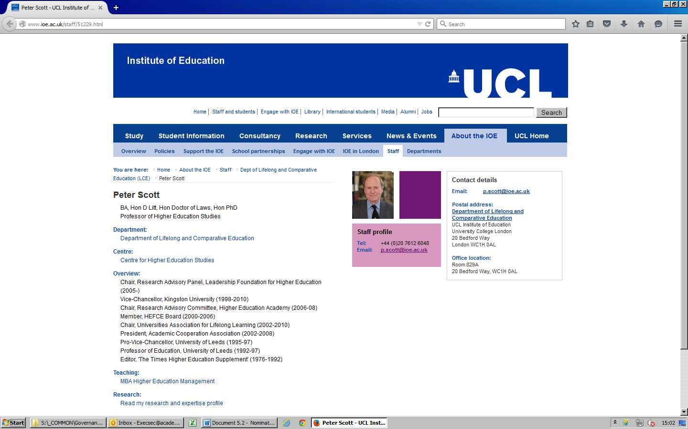
Role of the Honorary Treasurer (past Treasurer’s view)
The Treasurer is one of the directly elected officers of the Academy (the others being the President and Vice President(s)) and is de facto, a member of the Board of Trustees and a Director of the Academia Europaea Company Ltd. The Treasurer serves a term of 3 years, renewable for one further term. The Treasurer is also a counter signatory for the bank accounts of the Academy.
The Regulations state that "the duties include budgeting and control and the maintenance and supervision of the accounts and the receipt and expenditure of money on behalf of the AE and any other such duties as the Board may decide". In practice, the AE "budgets" on the basis of a rolling cash-flow forecast, which the Treasurer needs to monitor through the office of the Executive Secretary. Full Accounts with a Balance Sheet and Income/Expenditure statements are prepared once a year as required by law and this may involve discussion with the external Auditors.
In addition to monitoring the routine finances of the organisation, it is essential that the Treasurer takes a strategic view of the situation and can alert the Board if needed, on the longer term financial implications of any initiatives and policy changes. For example I (RE) have tried, not always successfully, to keep an eye on the finances of the Annual Meetings which are always financed locally but could have implications for the organisation. The same is true of the new Hubs. The policy with respect to Members contributions/subscriptions also has profound implications for the future of the AE's funding.
The Treasurer will find it useful to have at least a rudimentary acquaintance with accounting practices such as balance sheets, cash flow, out-turn etc. Since the AE is registered in the UK as a private Company limited by guarantee and also a registered charity, these will be governed by UK law. I have found it convenient to call on the London Office but with modern methods of communication this is a marginal advantage.
One thing the Treasurer is not, is the Academia's fundraiser, which is a job for the whole Board led by the President and the Executive Secretary. It is something that requires continuous effort.’
Roger Elliott
Treasurer (retired)

